Ho, Amy (from The Forester June 2003)
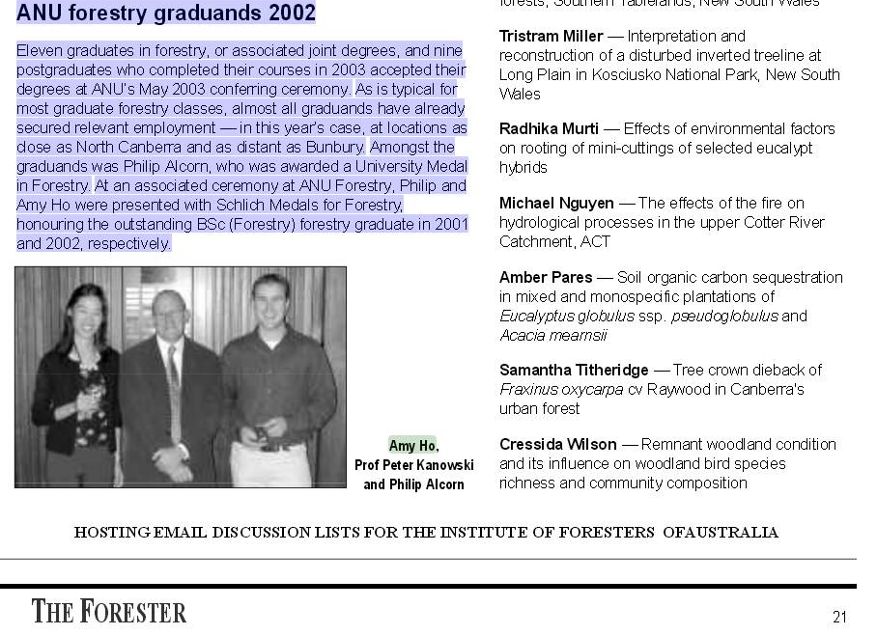
ANU forestry graduands 2002
Eleven graduates in forestry, or associated joint degrees, and nine postgraduates who completed their courses in 2003 accepted their degrees at ANU’s May 2003 conferring ceremony
.
As is typical for
most graduate forestry classes, almost all graduands have already secured relevant employment — in this years case, at locations as close as North Canberra and as distant as Bunbury
.
Amongst the graduands was Philip Alcorn, who was awarded a University Medal in Forestry
.
At an associated ceremony at ANU Forestry, Philip and Amy Ho were presented with Schlich Medals for Forestry ,
honouring the outstanding BSc (Forestry) forestry graduate in 2001 and 2002, respectively

Eleven ANU students completed Honours in forestry-related topics in November 2002; their thesis titles are listed below:
Philip Alcorn —
The effect of light availability,canopy gap size and within gap position on the growth of
Eucalyptus obliqua seedlings.
Amy Ho
— Particulate pollution capture and retention by Eucalyptus elata Denhn. in the ACT
.

.

